Technical Questions

1. SELECT * FROM users
2. SELECT * FROM users WHERE id=2

|  |  |  |
| --- | --- | --- |
| Id | userId | Meal |
|  |  |  |
|  |  |  |
|  |  |  |

1. Create table meals(

Id int,

UserId int,

Meal varchar(30),

PRIMARY KEY id,

FOREIGN KEY UserId);

1. Insert into meals (id, userid, meal)

Values(1, 1, “fajitas”);

1. Update users set name=”shamoontastic” where id=3;
2. Delete from meals where id=4;
3. Select * from meals inner join users where users.id=meals.userId
4. 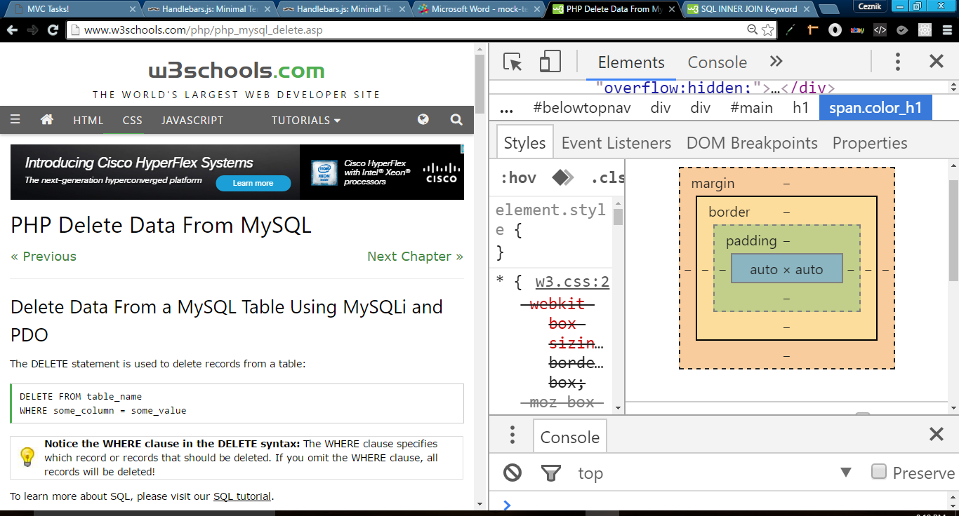

10.

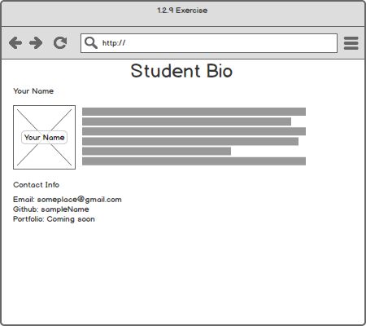

11.

Console returns Chris Orange

12. I would write a program to play sounds of an alpha lion roaring so as to discourage other lions from coming too close.